SIMATS ENGINEERING (SAVEETHA SCHOOL OF ENGINEERING)
Department of Computer Science and Engineering

ASSESSMENT TOOL 1 – Coding Challenge Task

Course Code: | CSA0612 | Course Title: | Design and Analysis of Algorithms
CO Assessed: | CO4: Articulation (BL4, BL5) | Assessment: | Assessment Tool 1 – Coding Challenge Task
Weightage: | 40% of CIA | Total Marks: | 100
CO4 Statement: | Solve optimization problems using dynamic programming and greedy strategies.
Student Name: | Yaswanthika Shree S | Reg. No.: | 192565069
Section / Batch: | B.E-CSE-CYBER SECURITY | Date: | 19.08.2026
Instructions to Students
- Answer the following question. Total Marks: 100.
- Carefully analyze the given questions.
- Write clear code for the given problem.
- Analyze the Time complexity and Space complexity of your code using dynamic programming and greedy strategies

Question Type | Focus Area | Questions
Coding Challenge Task | Focus on Code and analyze optimization problems using dynamic programming and greedy strategies | Q1

SECTION A – Coding Challenge Task

Q1.Count Subsets with Given Sum
Q2.Minimum Cost to Merge Stones
Q3.Minimum Falling Path Sum
Q4.House Robber Problem
Q5.Fibonacci with Memorization
Q6.Maximum Sum Increasing Subsequence
Q7.Unique Paths in Grid
Q8.Maximum Sum Circular Subarray
Q9.Longest Bitonic Subsequence
Q10.Maximum Sum Subarray

Code of Conduct
I YASWANTHIKA SHREE S(192565069) certify that this submission is my original work and that I have adhered to the guidelines specified for this assessment. I understand that any violation of academic integrity rules will result in disciplinary action.
Signature of the Student:

RUBRICS FOR CALCULATION

Coding Challenge Task

Criteria | Weightage | Level 4 (Exemplary) | Level 3 (Proficient) | Level 2 (Developing) | Level 1 (Beginning)
Problem Understanding | 20% | Clearly understands problem constraints, edge cases, and  competitive requirements | Understands problem with minor gaps in constraints | Partial understanding; misses key constraints | Misinterprets problem or constraints
Algorithm | 25% | Selects optimal algorithm with best time and space complexity for competitive constraints | Uses efficient algorithm with minor scope for improvement | Uses basic/inefficient approach | No clear algorithmic approach
Code Implementation | 20% | Writes correct, efficient, and clean code that passes all  constraints | Code works with minor errors or inefficiencies | Partially correct code; fails for some cases | Code does not execute or gives incorrect results
Competitive Performance | 20% | Solves problem within time limits and  handles large inputs effectively | Solves within acceptable time with minor delays | Struggles with time limits or larger inputs | Unable to solve within time constraints
Test Case Handling | 15% | Handles all test cases including edge and hidden cases | Handles most test cases | Misses important edge cases | Fails on multiple test cases

Marks Evaluation:
Criteria | Wt. | Level 4 – Exemplary | Level 3 – Proficient | Level 2 – Developing | Level 1 – Beginning
Problem Understanding | 20%
Algorithm | 25%
Code Implementation | 20%
Competitive Performance | 20%
Test Case Handling | 15%
Total Marks (100):

Faculty In-charge | Course Coordinator | Head of Department
Name: | Name: | Name:
Signature: | Signature: | Signature:
Date: | Date: | Date:

QUESTION 1:Count Subsets with Given Sum

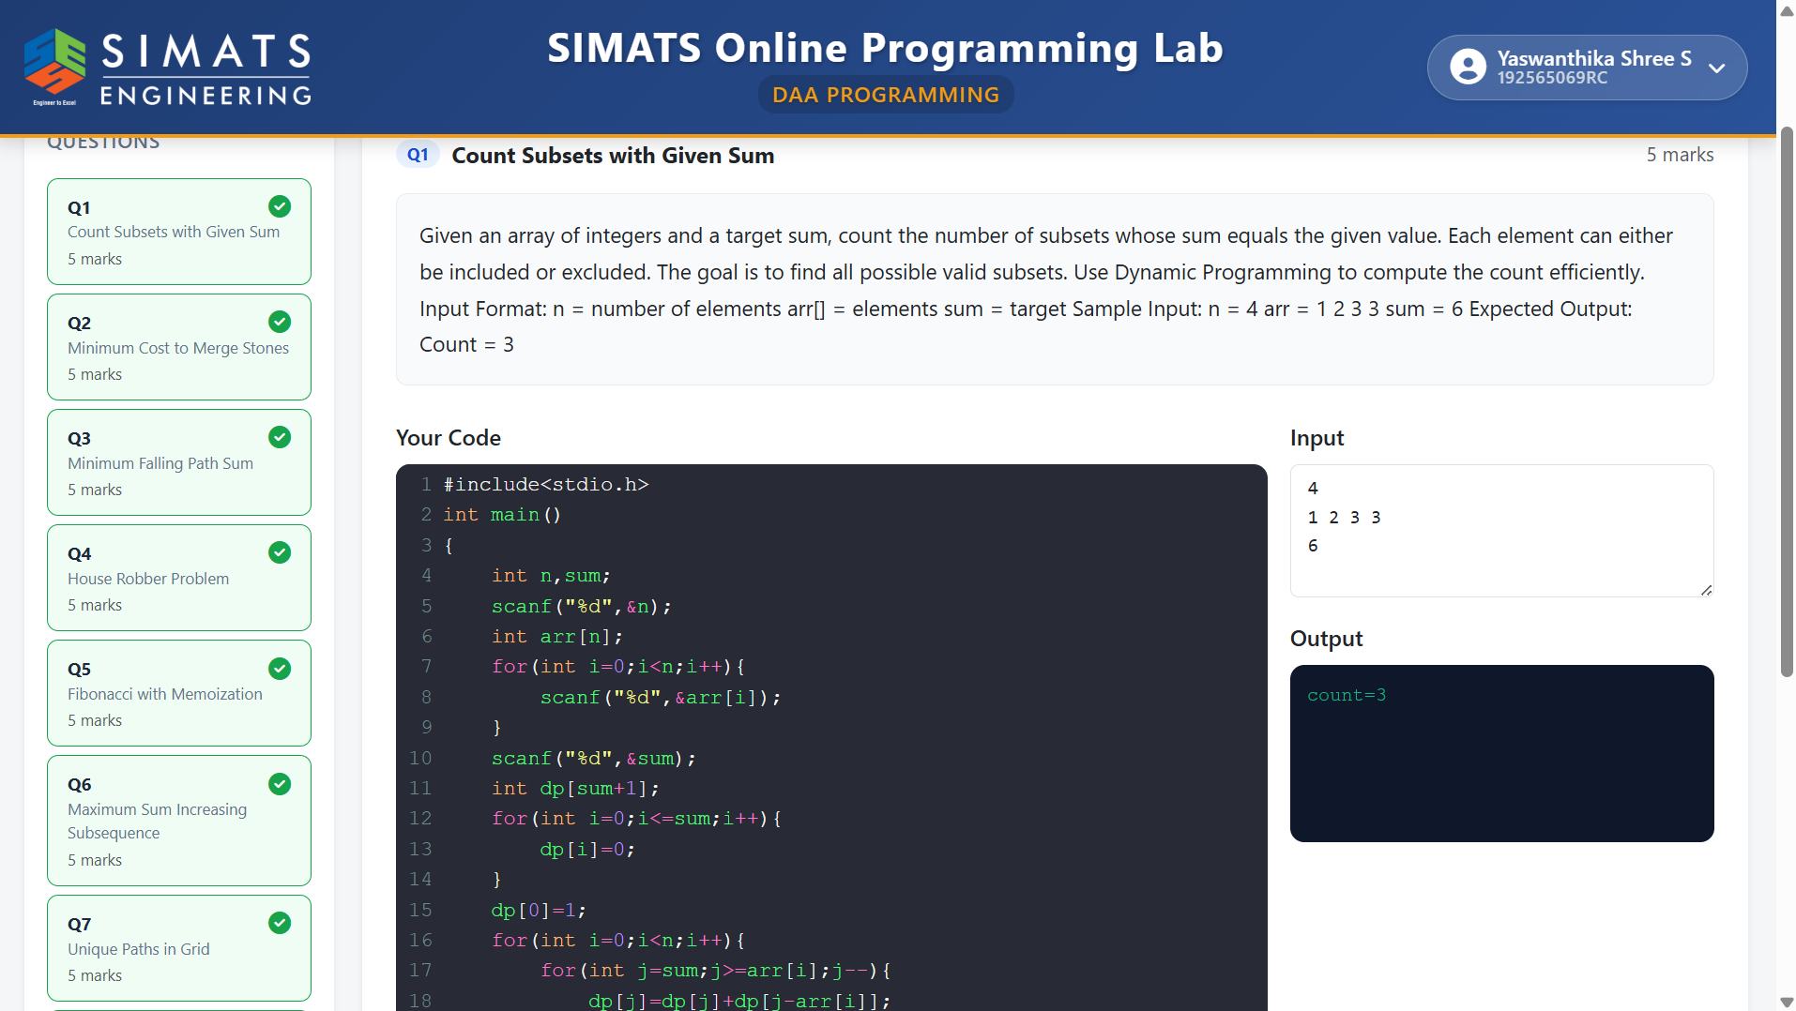

QUESTION 2:Minimum Cost to Merge Stones

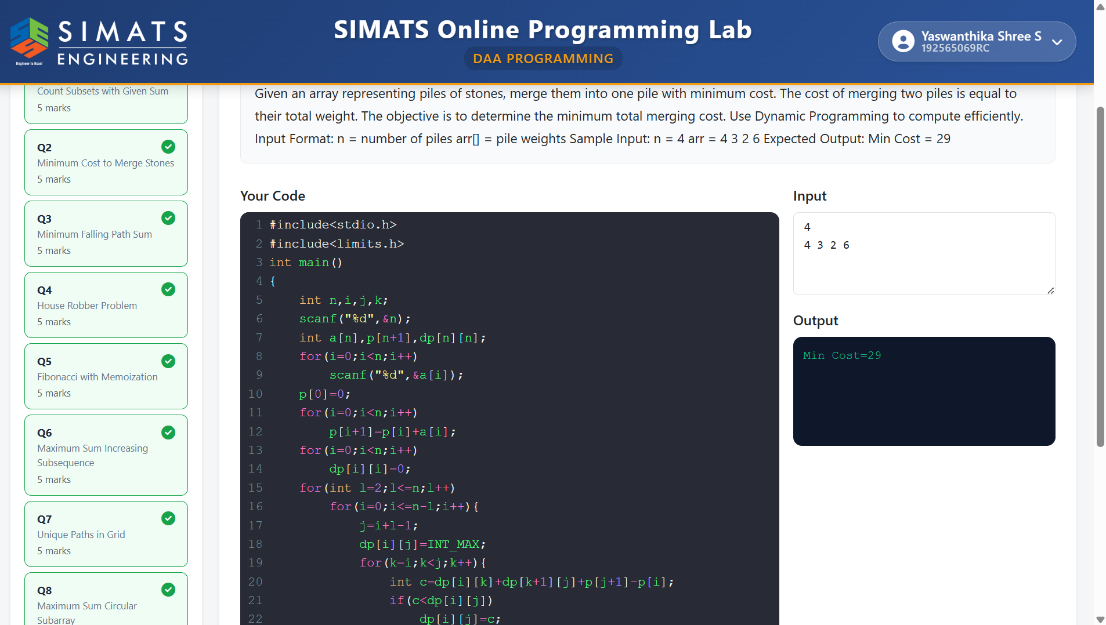

QUESTION 3:Minimum Falling Path Sum

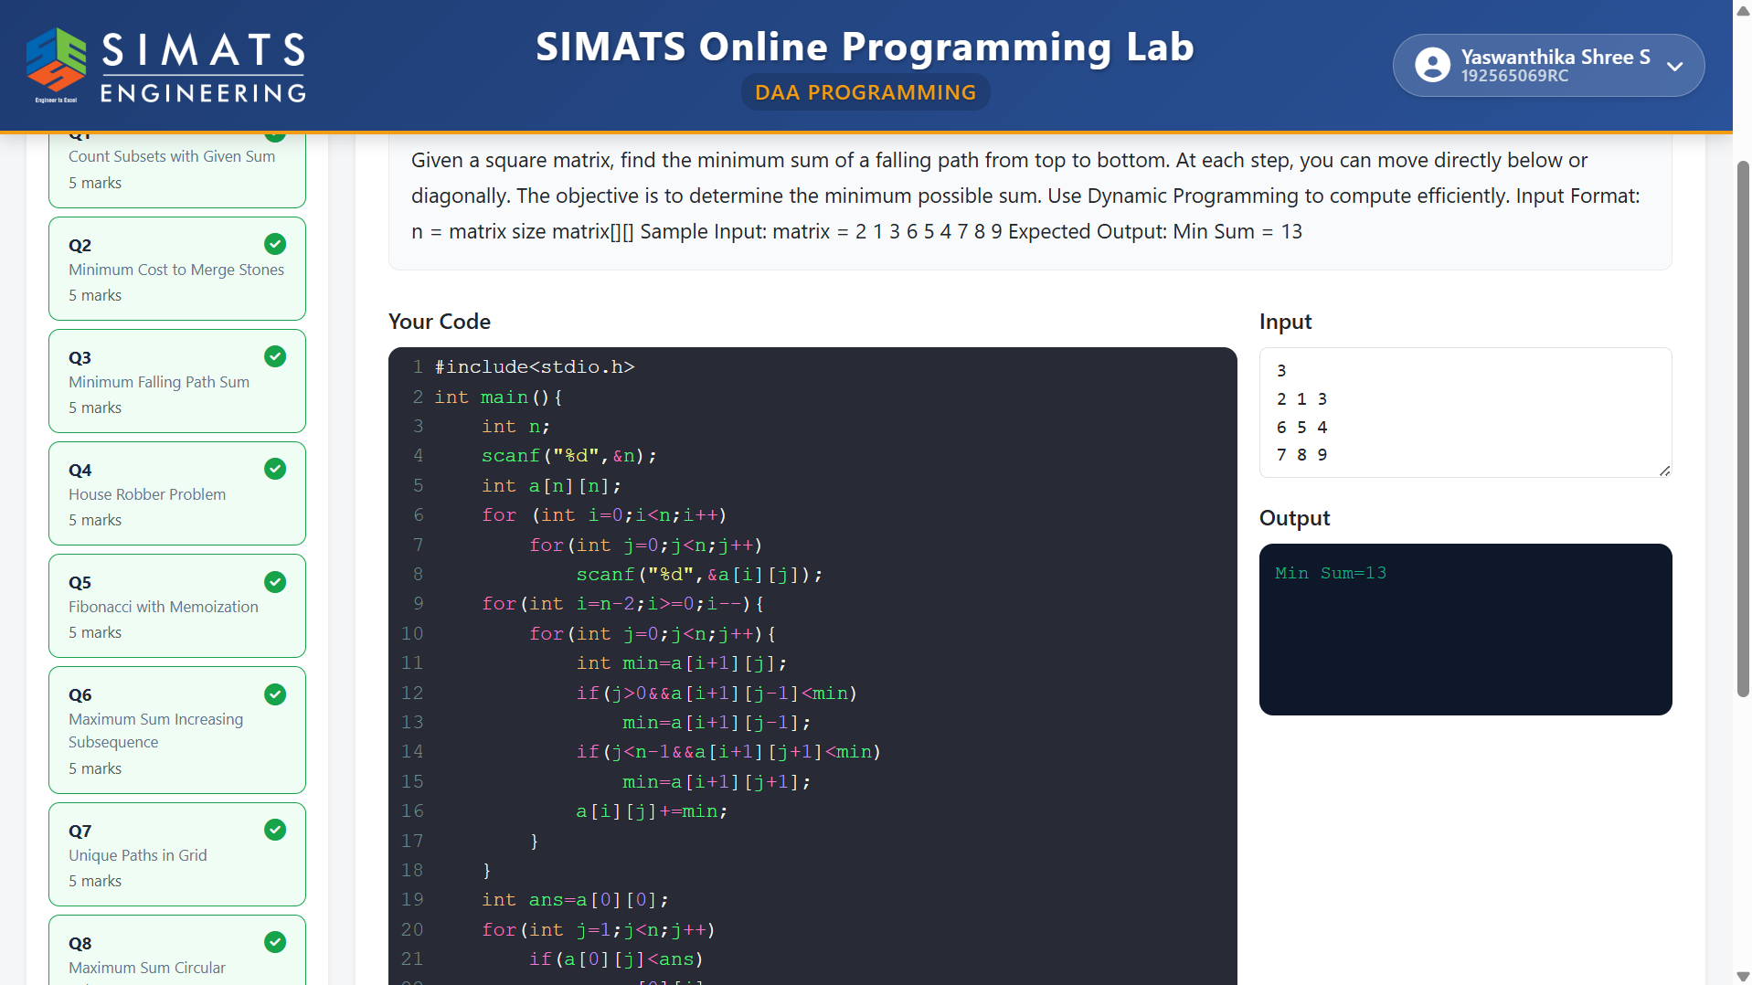

QUESTION 4:House Robber Problem

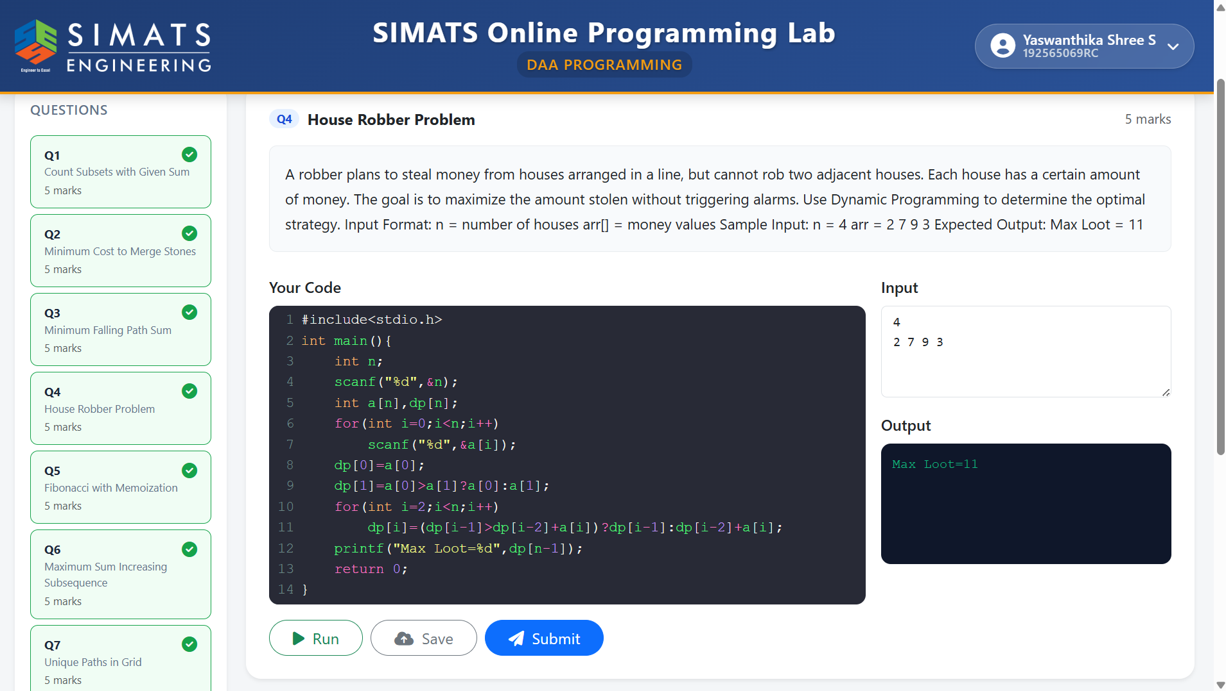

QUESTION 5:Fibonacci with Memorization

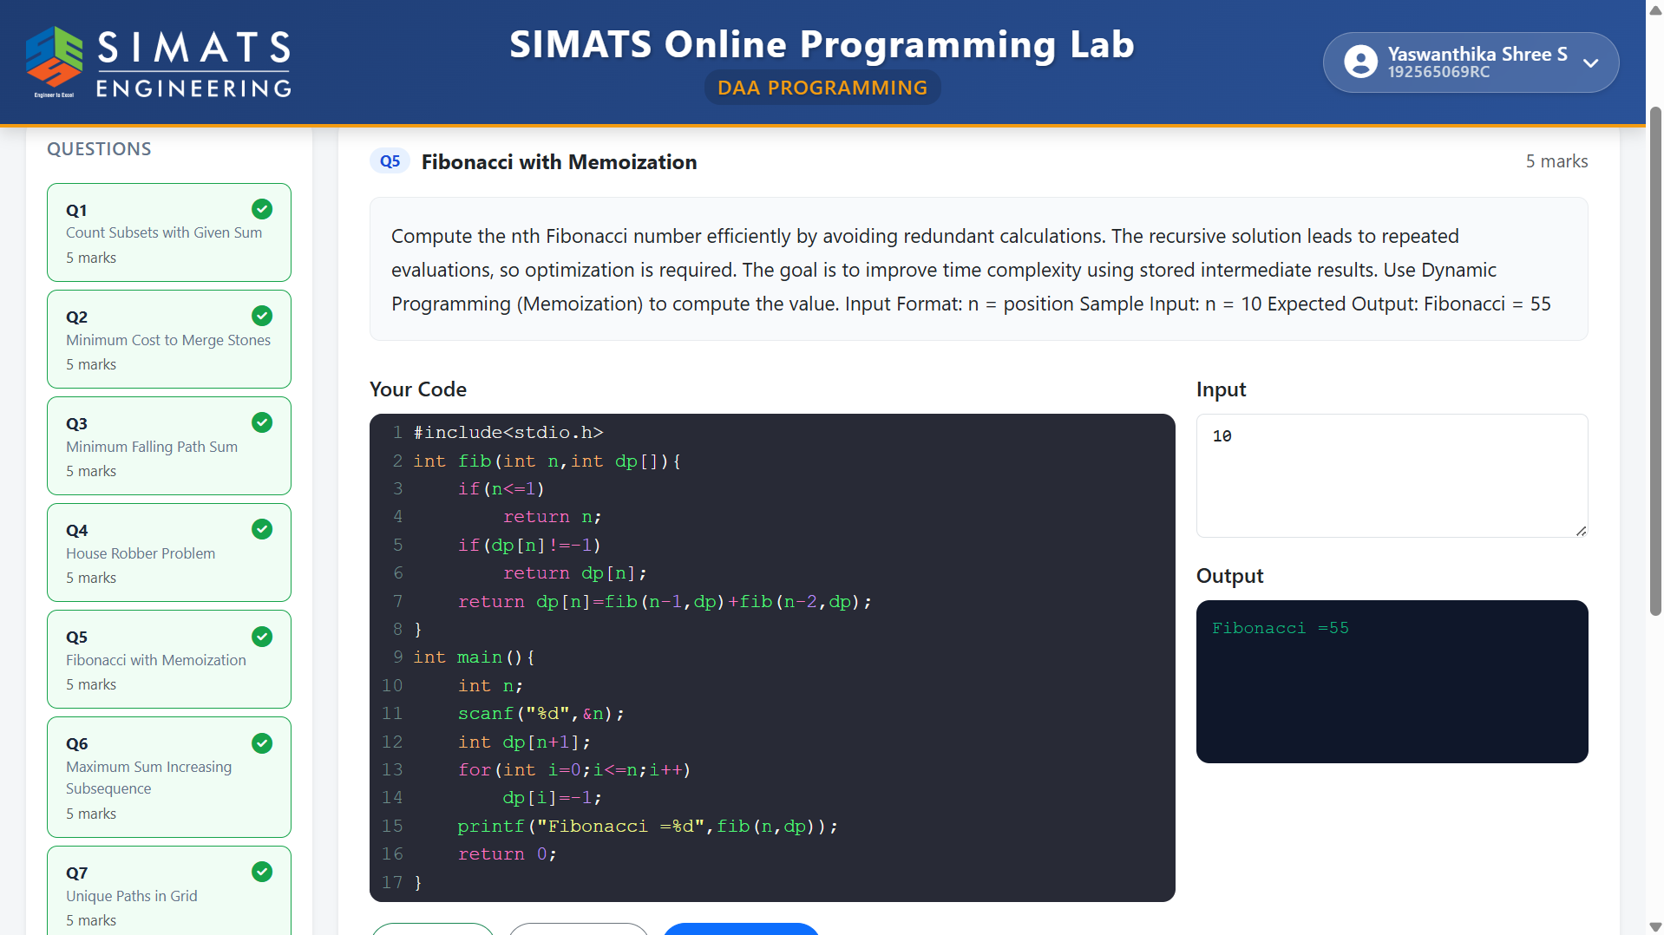

QUESTION 6:Maximum Sum Increasing Subsequence

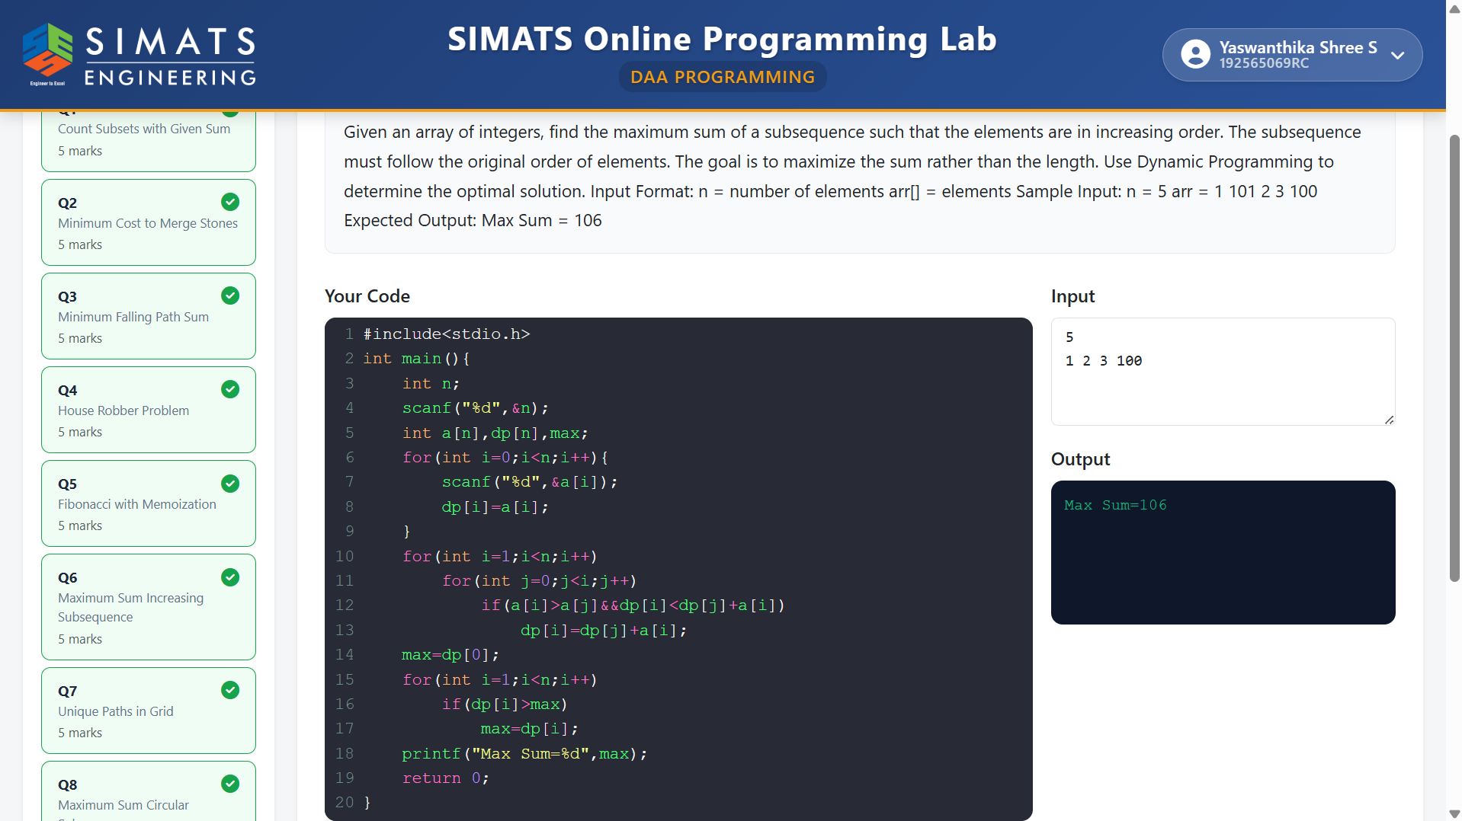

QUESTION 7:Unique Paths in Grid

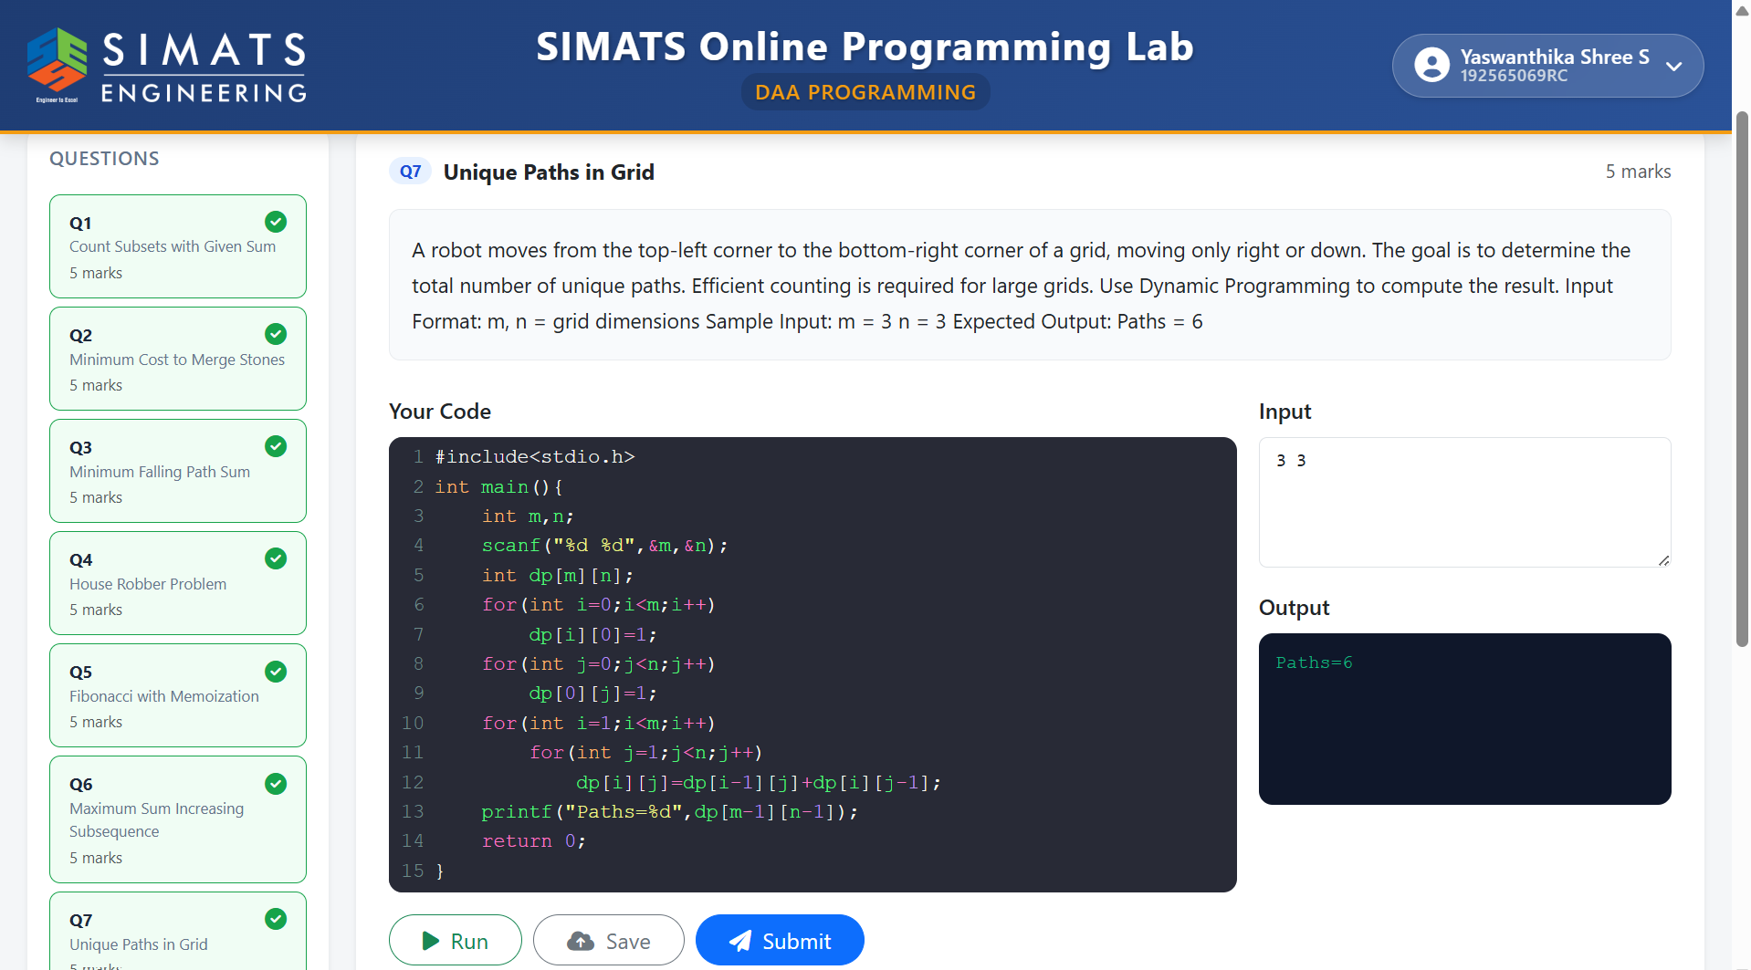

QUESTION 8:Maximum Sum Circular Subarray

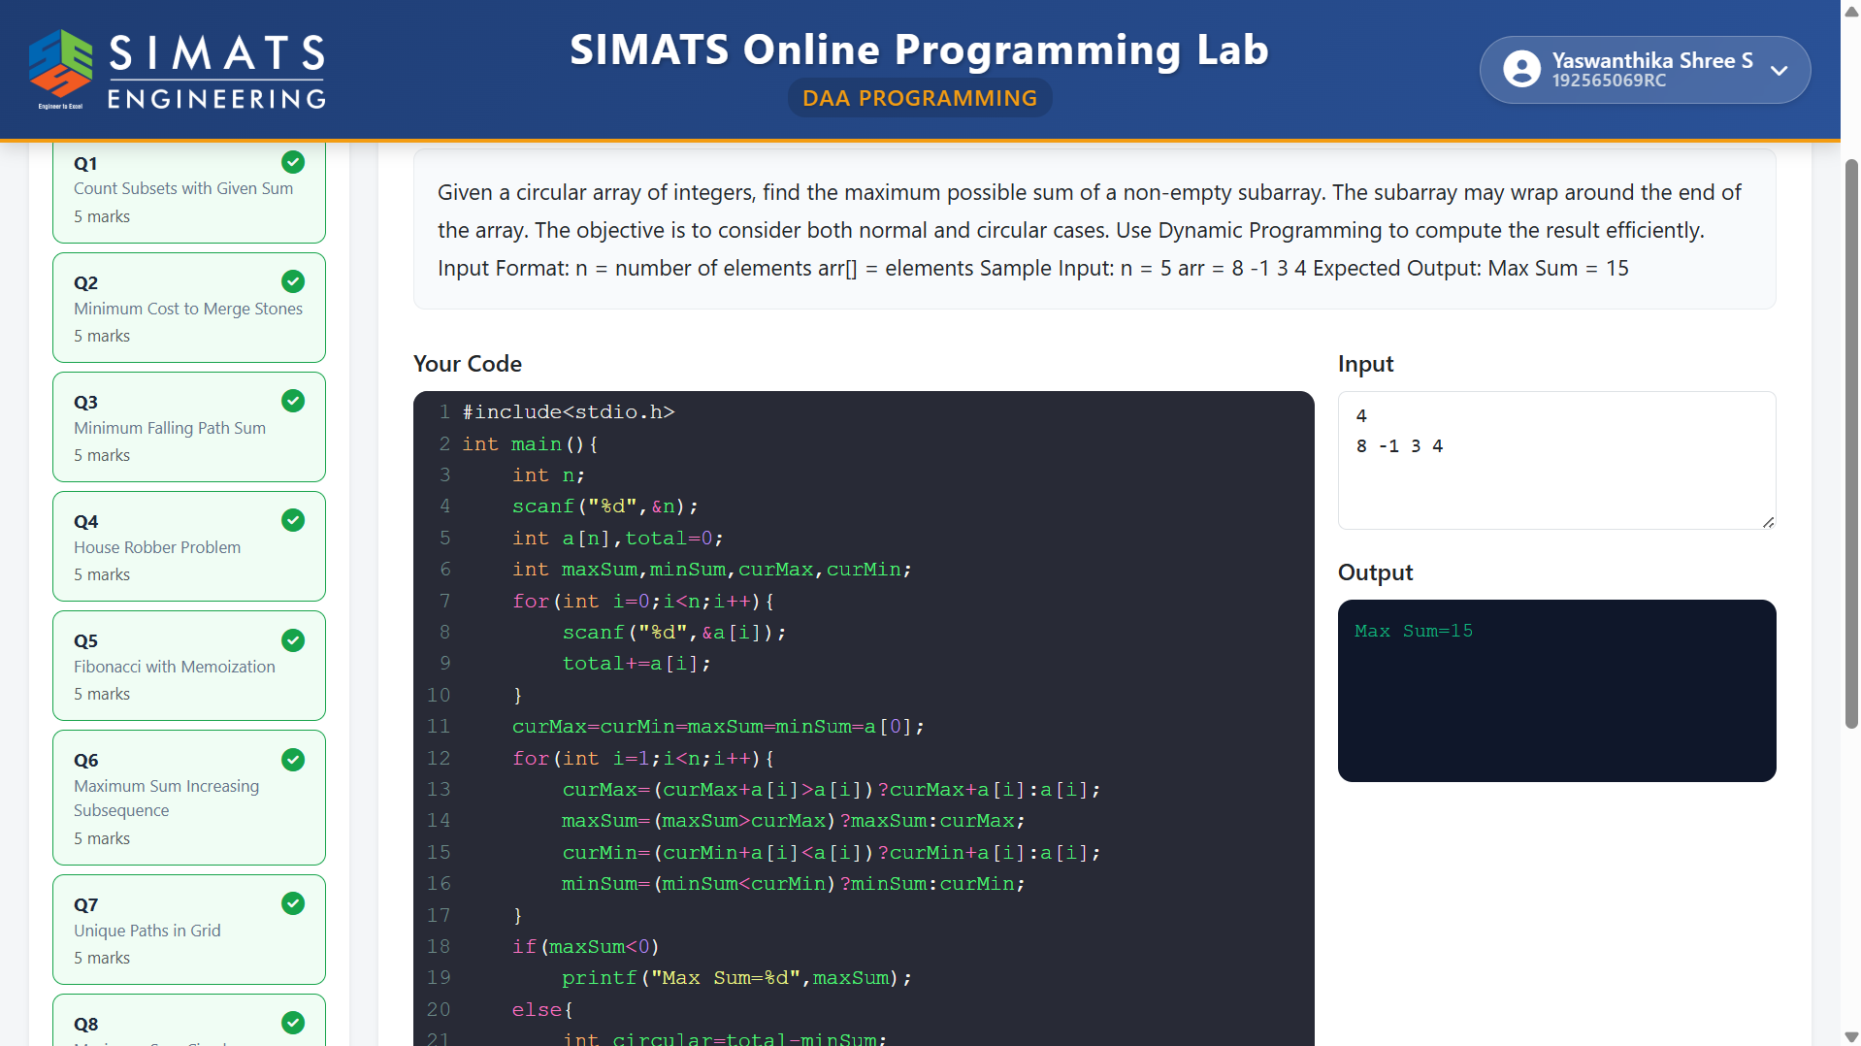

QUESTION 9:Longest Bitonic Subsequence

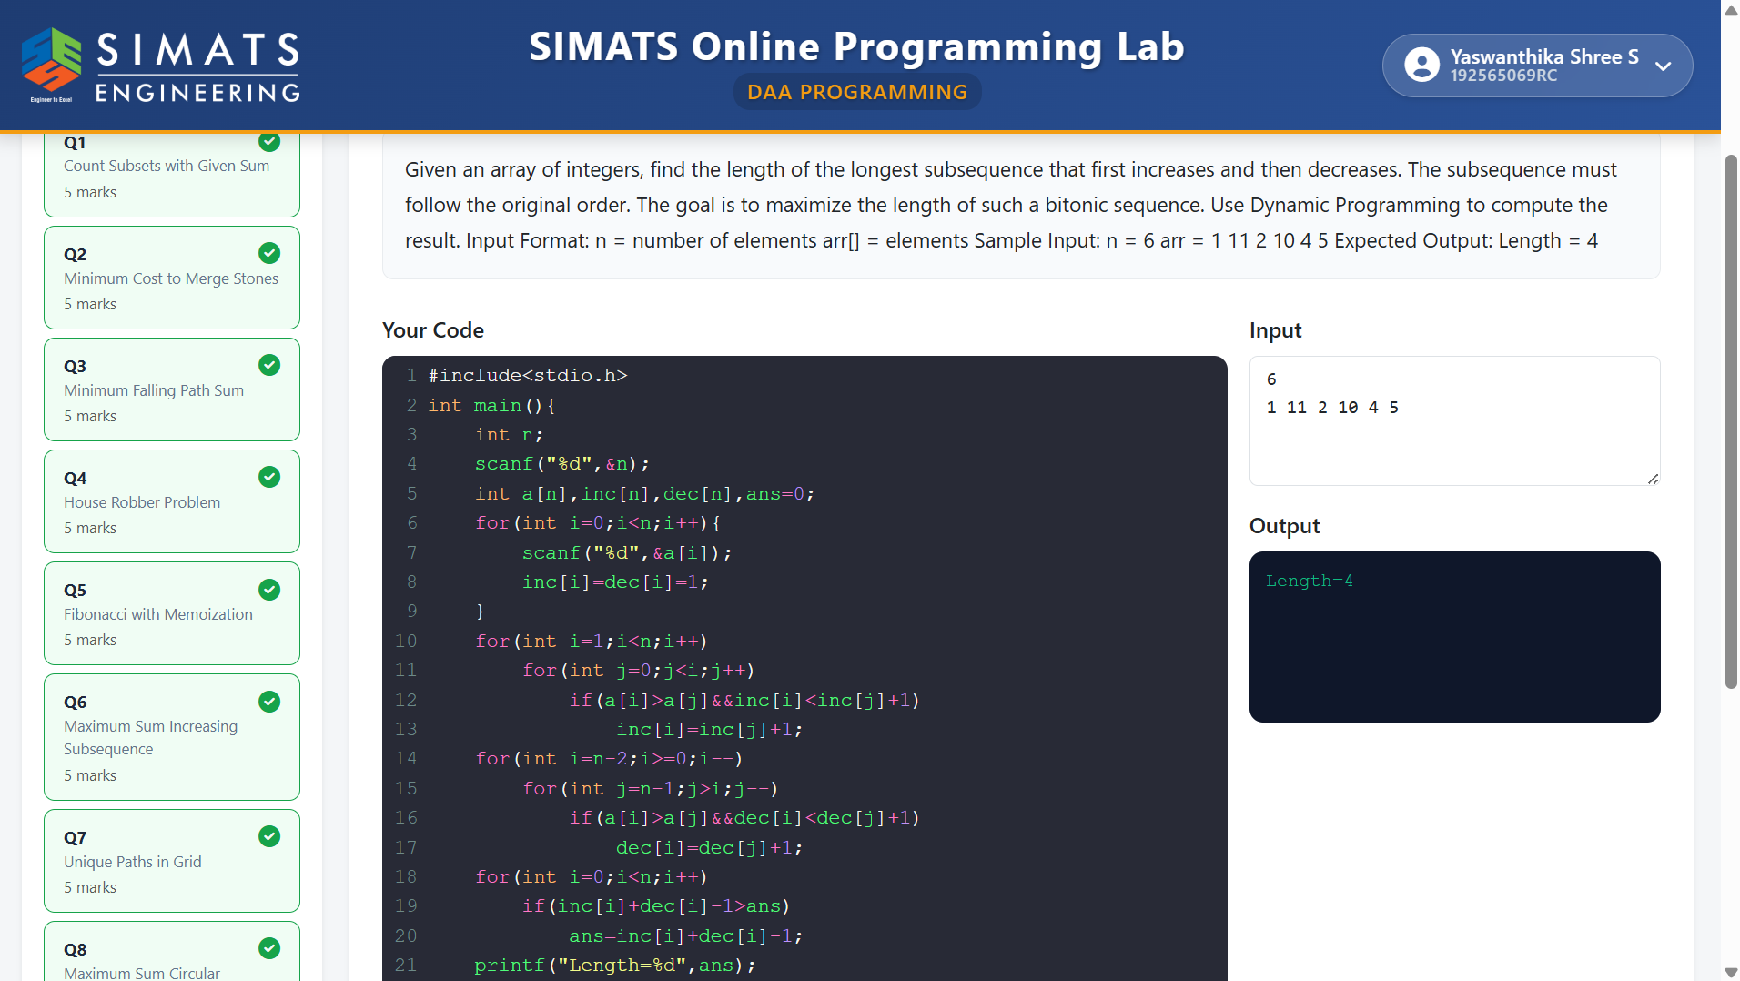

QUESTION 10:Maximum Sum Subarray

